Lesson Plan: School Objects

Description: This lesson plan is based on objects around the school. In this group I have 4 ELL students, in this block I’m teaching them basic concepts such as vocabulary words, sounds, calendar, blending (with heggerty). The language level is 3 Punjabi speakers, 1 Urdu speaker with a minimum amount of English. The 4 students are in Gr. 2 and 3. I see these students 5 days a week for 30 mins.

Big Idea:
Using language is creative and playful ways helps us understand how language works.

Curriculum Competencies:
Use sources of information and prior knowledge to make meaning
Use developmentally appropriate reading, listening, and viewing strategies to make meaning
Develop and apply expanding word knowledge

Content:
Features of Oral Language
Word Patterns, word families

Lesson Activities:
Teacher Activities | Student Activities | Time
Introduction (anticipatory set – “HOOK”):  Table Talk:  I will start up a small discussion about things they see around the school.  I then will begin my first ice breaker activity with “what’s in the bag”.  Students will feel the bag and let me know what they predict to be in the bag.  After some time, I will reveal what’s in the bag (a ruler). I will ask students how they felt about the activity and how they felt. | Here they are naming things they know or see around the school  Here students are feeling the bag to see what’s inside.  Students are making predictions.  Students are engaging in the conversation. Using words or hand motions. | 5 mins  5 mins
Body:  From here I will begin to take out my school supply cards with the words. I will go over each word and picture with them a couple of times.  Then I will begin my matching game, students are working as a group to match the pictures with the words.  I will give them about 10 mins to work on this, once I see them done, I will go over it by letting them know which ones they got correctly, and which ones didn’t match up. I let students fix their cards if they see any mistakes on their own. If not, I will go over which ones weren’t correct. | Students are repeating after me each word I say. Ex: “eraser” and they repeat that once I’m done.  Students are working together in matching the pictures to the words.  Here students are ether fixing their mistakes or listening and watching the teacher. | 10 mins
Closure:  Exit Ticket:  I will have students complete a matching worksheet. Here they are writing the school supply names beside the pictures.  5 mins before class ends, I will go over the words one more time and go over the worksheet (if done). | Here students are working on the worksheet independently.  Students are actively listening to the teacher. | 10 mins

Materials:

Worksheet:
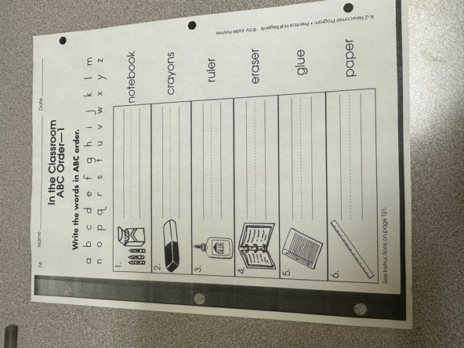

Matching cards:
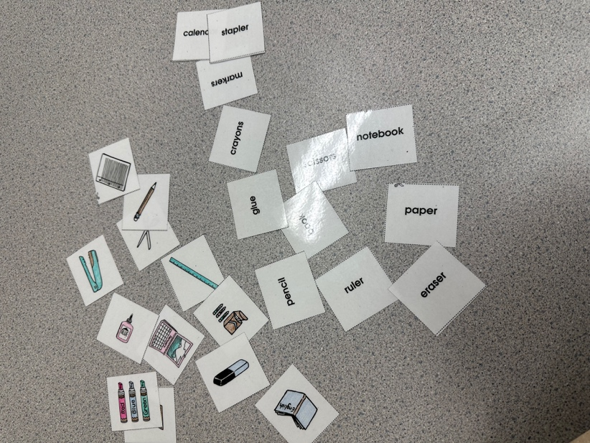

Assessment:
Formative Assessment: This will be done during the matching period of the lesson; here I will observe the students thinking skills and how well they communicate together.

Summative Assessment: This will be there exit ticket from the lesson, here I will have them do a worksheet on the objects we just learnt in class. I can see how their motor skills are and if they are able to remember things in class we just learnt.

Criteria | 1 | 2 | 3 | 4 | 5
Is the curriculum organized around "big" questions?
Are students involved in authentic reading and listening experiences?
Is there an attempt to draw on students' background knowledge and interests? Are students given choices?
Is the content meaningful? Does it serve a purpose for the learners?
Do students have opportunities to work collaboratively?
Do students read and write as well as speak and listen during their learning experiences?
Are students' primary languages and cultures valued, supported, and developed?
Am I reaching all students? Are students involved in activities that build their self-esteem and provide them with opportunities to succeed?

Strengths: I feel like I touched on all 4 aspects of learning. I believe my lesson has listening, speaking, reading and writing development. I provide students a more visual look of learning new words. I think matching is a great way to make connections between the word and picture. I think my activities are engaging and very hands on, students will remember much better if they are able to do more hands-on work.

Weakness: I don’t think my lessons is really supported culturally; this is still a challenging piece for me since I’m still trying to figure out how to teach students the basic things that also can make somewhat of a connection with them. I do ask them if they have used any of these objects back home, and if they have if they could share more about them.

References:

Chapter6: Literacy and the English Language Learner, in Haley and Austin’s Content-Based Second Language Teaching and Learning: An Interactive Approach. Haley, M.R., & Austin, T.Y. , 2014.

Haynes, Judie. Newcomer Program. Prentice Hall Regents ESL. 1997. Pg. 21

